Trong muc Controller add 1 controller: chon API Controller

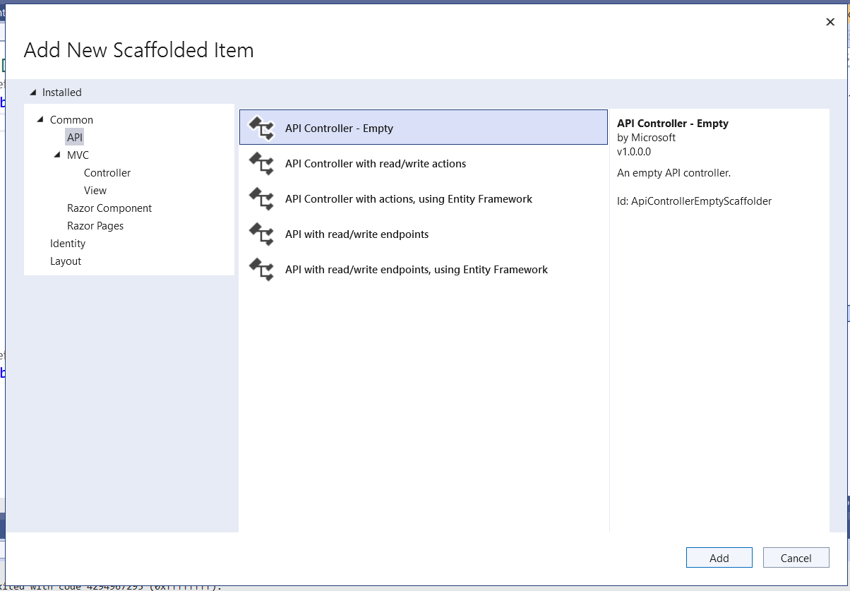

Them: using Ogani.Models;

QlbongDaContext db = new QlbongDaContext();

[HttpGet]

public IEnumerable<TrandauCauthu> GetAllCauThus()

{

var trandau = (from p in db.TrandauCauthus

select new TrandauCauthu

{

TranDauId = p.TranDauId,

CauThuId = p.CauThuId,

}).ToList();

return trandau;

}

[HttpGet("{TranDauID}")]

public IEnumerable<Cauthu> GetCauThuTheoTran(string tranDauId)

{

var trandauCauThus = (from tdct in db.TrandauCauthus

join ct in db.Cauthus on tdct.CauThuId equals ct.CauThuId

where tdct.TranDauId == tranDauId

select new Cauthu

{

CauThuId = ct.CauThuId,

HoVaTen = ct.HoVaTen,

Ngaysinh = ct.Ngaysinh,

// các thuộc tính khác của đối tượng CauThu

}).ToList();

return trandauCauThus;

}

Trong file Default:

Them doan code ajax:

<script>

function showCauthu(getUrl) {

var str = '';

$.ajax({

type: 'GET',

url: getUrl,

dataType: 'json',

success: function (data) {

$.each(data, function (key, val) {

str += '<li>'

str += '<p>' + val.cauThuId + '</p>'

str += '<p>' + val.hoVaTen + '</p>'

str += '</li>'

});

$('#displayCauthus').html(str);

},

Error: function (xhr) {

alert(xhr.responseText)

}

});

}

</script>

Sua doan code trong foreach:

var getUrl = "https://localhost:44315/api/playerapi/" + item.TranDauId; <li><a style="cursor:pointer" onclick="showCauthuTheoTran('@getUrl')">@item.TranDauId</a></li>

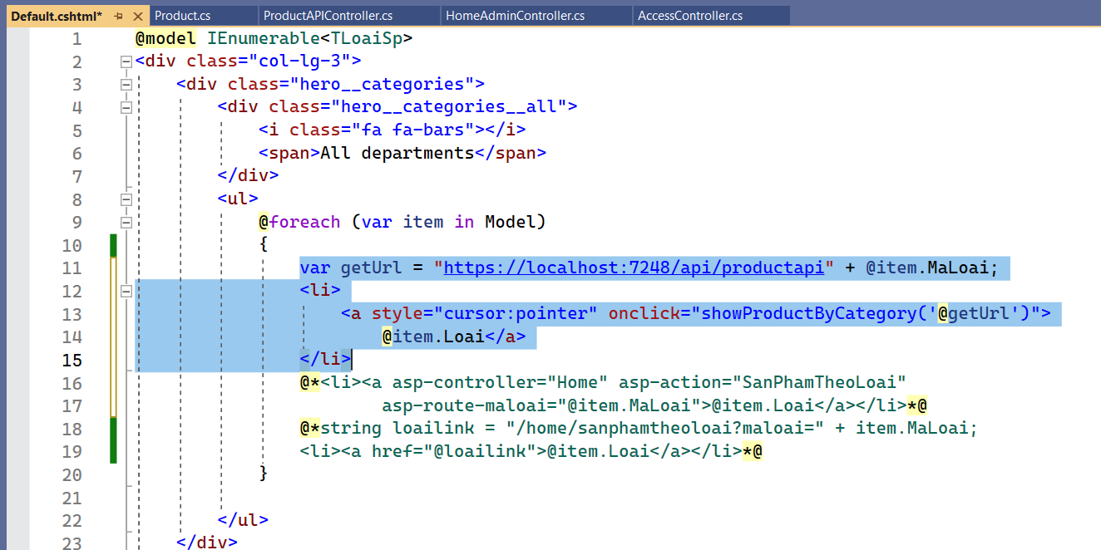

Sang LayoutOgani:

Tim kiem RenderBody()

Them id cho the div: id="displayCauthus"

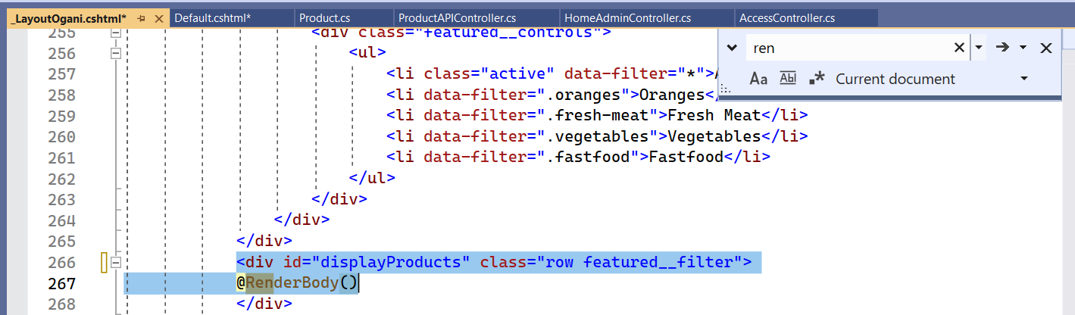

Copy doan code be PartialSanPham sang ben scripts vao doan str += `…`

@Model. -> ${val.}

<script>

function showProductByCategory(getUrl) {

var str = '';

$.ajax({

type: 'GET',

url: getUrl,

dataType: 'json',

error: function (response) {

alert(response.responseText);

},

success: function (data) {

$.each(data, function (key, val) {

str += `<div class="col-lg-3 col-md-4 col-sm-6 mix oranges fresh-meat">

<div class="featured__item">

<div class="featured__item__pic set-bg" data-setbg='../Images/${val.anhDaiDien}'

style="background-image: url('../Images/${val.anhDaiDien}');">

<ul class="featured__item__pic__hover">

<li><a href="#"><i class="fa fa-heart"></i></a></li>

<li><a href="#"><i class="fa fa-retweet"></i></a></li>

<li><a href="#"><i class="fa fa-shopping-cart"></i></a></li>

</ul>

</div>

<div class="featured__item__text">

<h6><a asp-controller="Home" asp-action="ChiTietSanPham" asp-route-MaSp="${val.maSp}">${val.tenSp}</a></h6>

<h5>${val.giaNhoNhat} đồng</h5>

</div>

</div>

</div>`

});

$('#displayProducts').html(str);

},

Error: function(xhr){

alert(xhr.responseText)

}

});

}

</script>